Data Visualization for Accidents

**Dataset:**

https://www.kaggle.com/datasets/sobhanmoosavi/us-accidents

**Project Thesis:**

* Focusing on the Austin – Metro area, analyze and visualize trends of highly accident-prone areas, times, and weather conditions.

**Questions to ask the Data (3 views):**

* Day vs Night (Time of day)
* Area related accidents (Lat, Long)
* Distance of affected area (in miles)
* Sunny vs Cloudy (need to bring in another data set on weather)

**Screenshots of metadata:**

* See website

**Inspiration Screenshots:**

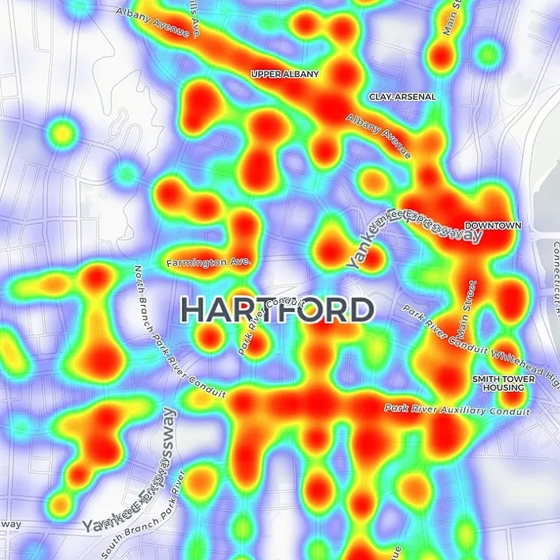

(Ctnewsjunkie.com -- Heat map of a single city traffic accidents/incidents) SEVERITY?

(above https://toddwschneider.com/posts/nyc-motor-vehicle-collisions-map/)

**Requirements Checklist:**

* Visualizations created with:
  + Mostly Python (Plotly, pandas, matplotlib)
  + Possibly adding Java if needed for mapping
* Data will be stored in and extracted from
  + PostreSQL
* Include one Java or Python library that we did not cover
  + Geopy / nominatim
* User-driven interaction (HTML menu, dropdown, and/or textboxes to display Java powered visualizations)
  + <https://plotly.com/python/#controls>
  + Using above link to create interactivity
  + Drop down menus

**Github Link:**

https://github.com/fincherc/data-visualizations-project-3

**Acknowledgements:**

If you use this dataset, please kindly cite the following papers:

* Moosavi, Sobhan, Mohammad Hossein Samavatian, Srinivasan Parthasarathy, and Rajiv Ramnath. “[A Countrywide Traffic Accident Dataset](https://arxiv.org/abs/1906.05409).”, 2019.
* Moosavi, Sobhan, Mohammad Hossein Samavatian, Srinivasan Parthasarathy, Radu Teodorescu, and Rajiv Ramnath. ["Accident Risk Prediction based on Heterogeneous Sparse Data: New Dataset and Insights."](https://arxiv.org/abs/1909.09638) In proceedings of the 27th ACM SIGSPATIAL International Conference on Advances in Geographic Information Systems, ACM, 2019.

Bonus Inspiration:

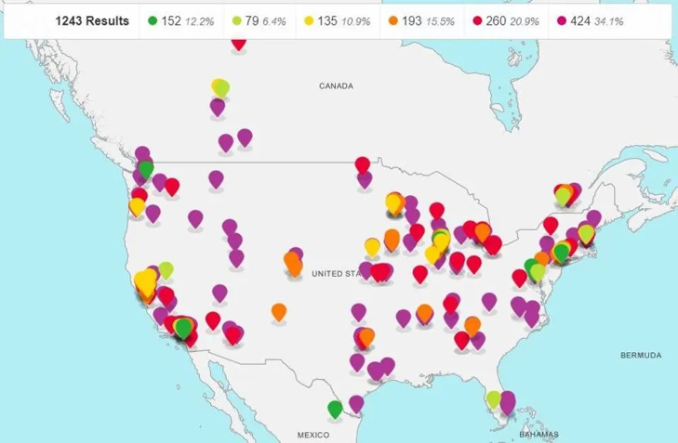

(Forbes.com -- In more than 1,200 towns and cities around the world, not a single person was killed in a road traffic crash in at least one calendar year since 2009. Some municipalities [reported zero traffic deaths](https://www.dekra-vision-zero.com/) for multiple years.)

<https://www.dekra-vision-zero.com/map>

(above is the interactive version ^^)